

Digital Notes
(Subject Name:- Object Oriented Programming Using Java)
(Subject Code :- BCA 2004T)
Course Name - BCA
Year – 1st )

UNIT 1
Object-Oriented Programming (OOP) is a programming paradigm based on the concept of objects that contain data (fields) and behavior (methods). It focuses on designing software that closely represents real-world entities. It is used to:
- Improves code reusability
- Enhances maintainability and scalability
- Makes programs easier to understand and manage
- Closely models real-world entities
Real-world ATM example (no code first)
- What is the object? → ATM
- What data does ATM have?
  - balance
  - card number
- What actions does ATM do?
  - withdraw cash
  - check balance
Data + actions belong to ATM, not outside.

Class
A Class is a user-defined blueprint or prototype from which objects are created. It represents the set of properties or methods that are common to all objects of one type. Using classes, you can create multiple objects with the same behavior instead of writing their code multiple times. In general, class declarations can include these components in order:
- Modifiers: A class can be public or have default access (Refer to this for details).
- Class name: The class name should begin with the initial letter capitalized by convention.
- Body: The class body is surrounded by braces, { }.
Example: A Car represents a class (blueprint), while BMW, Mercedes, and Audi represent objects (instances) created from that class.
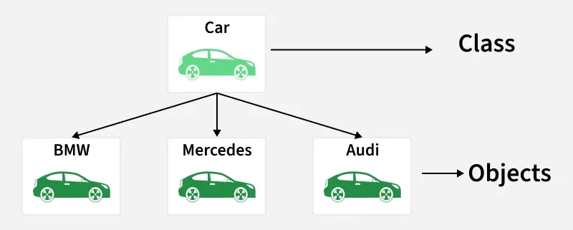

2. Object
An Object is a basic unit of Object-Oriented Programming that represents real-life entities. A typical Java program creates many objects, which as you know, interact by invoking methods. The objects are what perform your code, they are the part of your code visible to the viewer/user. An object mainly consists of:
- State: It is represented by the attributes of an object. It also reflects the properties of an object.
- Behavior: It is represented by the methods of an object. It also reflects the response of an object to other objects.
- Identity: It is a unique name given to an object that enables it to interact with other objects.
- Method: A method is a collection of statements that perform some specific task and return the result to the caller.
What is an Object?
An object is anything you can see or imagine in real life.
Examples:
- Student
- Mobile
- Car
- Book
Let’s take ONE example — Student
A Student has DATA
These are details:
- Name
- Roll number
- Marks
A Student does WORK
These are actions:
- Study
- Give exam
- Show result
DATA + WORK = OBJECT

Benefits of OOP
- Modularity
OOPS divides a program into small parts called objects and classes. Each class performs a specific task, which makes the program well-structured and easy to understand.
- Reusability
Using inheritance, existing classes can be reused to create new classes. This reduces code duplication and saves development time.
- Maintainability
Programs written using OOPS are easier to maintain and modify. Changes in one part of the code do not affect other parts.
- Data Security (Encapsulation)
OOPS provides data hiding using access specifiers (private, protected, public). This protects data from unauthorized access.
- Flexibility
With polymorphism, the same function or method can behave differently in different situations, making the program more flexible.
- Easy Debugging and Testing
Since the program is divided into objects, errors can be easily located and fixed without disturbing the whole program.
- Real-World Modeling
OOPS allows programs to be designed based on real-world entities like objects, attributes, and behaviors, making problem-solving easier.
- Scalability
Large and complex software systems can be developed and expanded easily using OOPS concepts.
Applications of OOPS
- Real-Time Systems
OOPS is used in real-time systems like air traffic control, medical monitoring systems, and robotics where reliability and accuracy are required.
- Web Applications
OOPS is widely used in developing websites and web applications using languages like Java, Python, and JavaScript (backend frameworks).
- Mobile Applications
Android (Java/Kotlin) and iOS (Swift) app development uses OOPS concepts to manage complex app structures.
- Game Development
Games use OOPS to represent characters, weapons, levels, and actions as objects, making game design easier.
- Desktop Applications
Software like text editors, media players, and accounting software are developed using OOPS-based languages.
- Enterprise Software
Large business applications such as banking systems, ERP, and CRM software use OOPS for scalability and maintainability.
- Database Systems
OOPS concepts are used in object-oriented databases and in mapping objects to relational databases (ORM).
- Simulation and Modeling Systems
OOPS is used to simulate real-world systems like weather forecasting, traffic systems, and scientific models.
- Artificial Intelligence and Machine Learning
OOPS helps in organizing complex AI systems using reusable classes and objects.
- Distributed Systems
OOPS supports development of distributed and network-based applications where objects communicate over networks.

Java
- Java is a high-level, object-oriented programming language developed by Sun Microsystems in 1995. It is mostly used for building desktop applications, web applications, Android apps and enterprise systems
- Java is a platform-independent language, which means code written in Java can run on any device that supports the Java Virtual Machine (JVM).
- Syntax and structure are similar to C-based languages like C++ and C#.
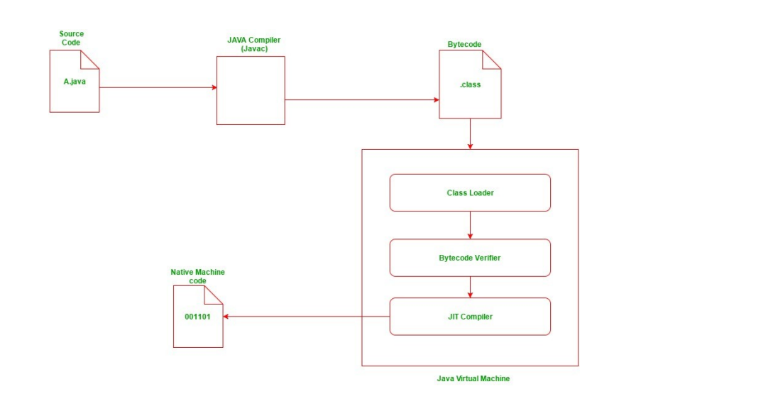

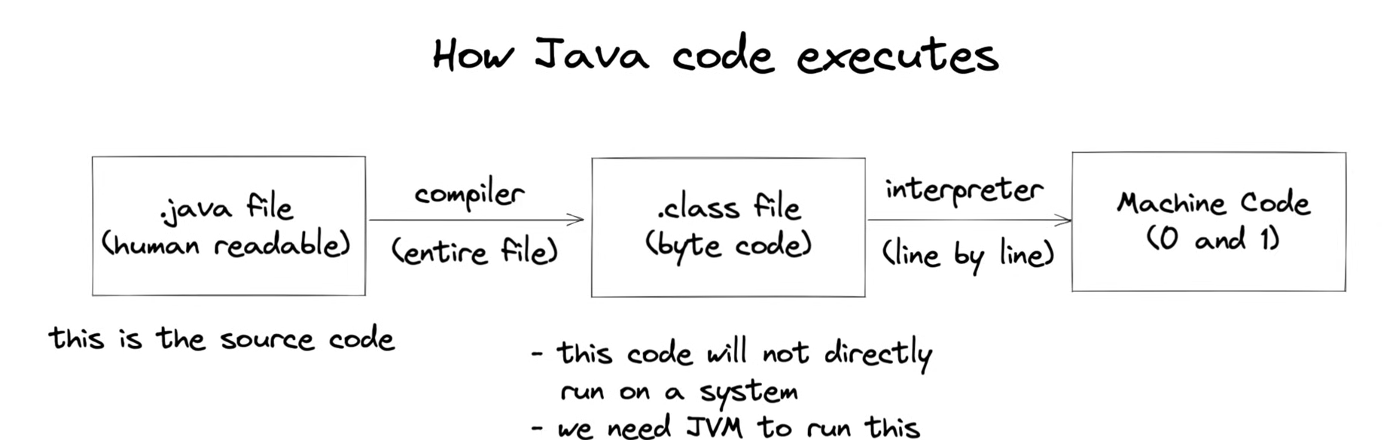
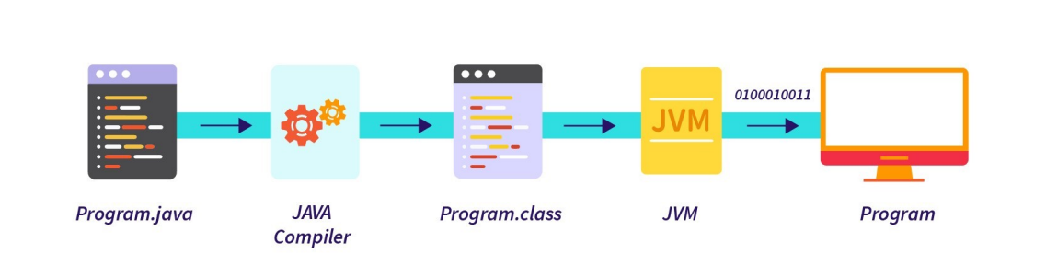

Basic Code Example
The following is a simple program that displays the message “Hello, World!” on the screen.
public class HelloWorld {
public static void main(String[] args) {
System.out.println("Hello World!");
}
}
Step 1: Writing the Java Program
Example:
- Class name: HelloWorld
- File name: HelloWorld.java

Step 2: Compiling the Java Program
Once the Java program is written, it needs to be compiled. Compilation is the process of converting the human-readable Java code into bytecode, which can be understood by the Java Virtual Machine (JVM).
Command to compile:
javac. HelloWorld java
Here:
- javac is the Java compiler.
- HelloWorld .java is the file to compile.
NOTE :
If there are no errors, this command will create a file called HelloWorld .class. The .class file contains bytecode, which is a platform-independent code that the JVM can execute. If there are errors, the compiler will show them in the terminal. You need to fix the errors before running the program.
Step 3: Executing the Java Program
After successful compilation, you can run the program using the Java interpreter.
Command to run:
Java HelloWorld
Here:
- java is the Java interpreter.
- HelloWorld is the name of the class containing the main method (do not include .class).
Byte code is an intermediate code between the source code and machine code. It is a low-level code that is the result of the compilation of a source code which is written in a high-level language. It is processed by a virtual machine like Java Virtual Machine (JVM).
Machine Code:
Machine code is a set of instructions that is directly machine-understandable and it is processed by the Central Processing Unit (CPU). Machine code is in binary (0's and 1's) format which is completely different from the byte code and source code.

Java JDK, JRE and JVM
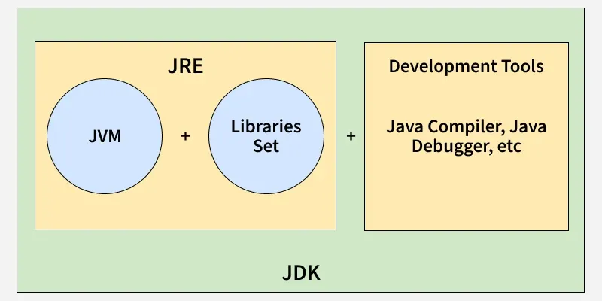
What is JVM?
JDK (Java Development Kit)
JDK is a software development kit used to build Java applications. It contains the JRE and a set of development tools.
- Includes compiler (javac), debugger, and utilities like jar and javadoc.
- Provides the JRE, so it also allows running Java programs.
Working of JDK:
- Source Code (.java): Developer writes a Java program.
- Compilation: The JDK’s compiler (javac) converts the code into bytecode stored in .class files.
- Execution: The JVM executes the bytecode, translating it into native instructions.
JRE (Java Runtime Environment)
JRE provides an environment to run Java programs but does not include development tools. It is intended for end-users who only need to execute applications.
- Contains the JVM and standard class libraries.
- Provides all runtime requirements for Java applications.
- Does not support compilation or debugging.

JVM (Java Virtual Machine)
JVM is the core execution engine of Java. It is responsible for converting bytecode into machine-specific instructions.
- Part of both JDK and JRE.
- Performs memory management and garbage collection.
- Provides portability by executing the same bytecode on different platforms.

Introduction to Simple Java Program
public class HelloWorld {
public static void main(String[] args) {
System.out.println("Hello World!");
}
}

public class HelloWorld
This line is used to create a class.
In Java, everything is written inside a class.
A class is like a container or blueprint that holds data and functions.
- public → It is an access modifier. It means this class can be used from anywhere.
- class → This is a keyword used to create a class.
- HelloWorld → This is the name of the class.
Important rule:
The class name and file name must be the same.
So the file will be saved as:
HelloWorld.java

public static void main(String[] args)
It is called the main method.
Execution of every Java program starts from main().
Let’s break it into parts:
public
It means the method is accessible from anywhere.
JVM (Java Virtual Machine) needs to call this method, so it must be public.
static
static means we don’t need to create an object to run this method.
JVM can call it directly.
If static was not written, Java would first need to create an object — which is not practical for starting execution.

void
void means this method does not return any value.
It only performs work (like printing output).

main
This is the method name.
Java always looks for main to start program execution.
If you change the name, the program will compile but will not run.

What is String[] args?
It means:
An array of String values named args.
- String → Text data type
- [] → Array (multiple values)
- args → Variable name (you can change name)
So it stores multiple text inputs.
Suppose you run program like this:
java Test Rahul 21 Delhi
Here:
- Rahul
- 21
- Delhi
These are command line inputs.
Java automatically stores them in args

5. System.out.println("Hello World!");
This line prints the output on the screen.
Let’s understand it part by part.

System
System is a predefined class in Java.
It belongs to java.lang package.
It provides system-related features.

out
out is an object of PrintStream class.
It is connected to the console (screen).
So anything written with out will be displayed on screen.

println
println is a method used to print text.
- print() → Prints without new line
- println() → Prints with new line
So after printing, the cursor moves to next line.

"Hello World!"
This is the message we want to print.

JDK vs JRE vs JVM
Aspect | JDK | JRE | JVM
Purpose | Used to develop Java applications | Used to run Java applications | Executes Java bytecode
Platform Dependency | Platform-dependent (OS specific) | Platform-dependent (OS specific) | JVM is OS-specific, but bytecode is platform-independent
Includes | JRE + Development tools (javac, debugger, etc.) | JVM + Libraries (e.g., rt.jar) | ClassLoader, JIT Compiler, Garbage Collector
Use Case | Writing and compiling Java code | Running a Java application on a system | Convert bytecode into native machine code

Java Tokens
In Java, Tokens are the smallest elements of a program that is meaningful to the compiler. They are also known as the fundamental building blocks of the program.
When you write a Java program, the compiler does Lexical Analysis (first phase of compilation).
In this phase, the compiler breaks the whole source code into small pieces called tokens so it can understand the program structure.
int a = 10;
This single line is divided into tokens:
Code Part | Token Type
int | Keyword
a | Identifier
= | Operator
10 | Literal
; | Separator
Tokens can be classified as follows:
- Keywords
- Identifiers
- Constants/Literals
- Operators
- Separators
1. Keyword
Keywords are pre-defined or reserved words in a programming language. Each keyword is meant to perform a specific function in a program. Since keywords are referred names for a compiler, they can’t be used as variable names because by doing so, we are trying to assign a new meaning to the keyword which is not allowed.
Example
int, float, if, else, while, class, public, static, void
Example in code:
public class Test
Here:
- public → Keyword
- class → Keyword

2. Identifiers
Identifiers are used as the general terminology for naming of variables, functions and arrays. These are user-defined names consisting of an long sequence of letters and digits with either a letter or the underscore (_) as a first character. Identifier names must differ in spelling and case from any keywords.
. Examples of valid identifiers:
MyVariable
MYVARIABLE
x
x1
_myvariable
$myvariable
sum_of_array
3. Literals
Literals in Java are fixed values that appear directly in code and represent constant data. Common kinds include integer (10), floating-point (3.14), boolean (true/false), character ('A'), string ("Java")
Syntax:
int a = 10;
Here 10 is a literal.

4. Operators
Operators in Java are special symbols that perform operations on operands—variables and values. Java groups them into categories like arithmetic (+ - * / %), relational (< > == != >= <=), logical (&& || !), assignment (= +=), unary (++ --), bitwise (& | ^ ~ << >> >>>), and ternary (?:). They enable calculations, comparisons, decision-making, and data manipulation.

5. Separators
Separators in Java, also called delimiters, are characters that structure Java code: parentheses (), braces {}, brackets [], semicolon ;, comma ,, and dot .. They group statements, define blocks, index arrays, terminate statements, separate parameters, and access members
int variable; //here the semicolon (;) ends the declaration of the variable

Java Statements

A computer program is a list of "instructions" to be "executed" by a computer.
In a programming language, these programming instructions are called statements.

System.out.println("Hello");

Java Comments
In Java, comments are non-executable statements that explain code and improve readability. They are ignored by the compiler and do not affect program execution.
- Enhance code readability and maintainability.
- Useful for debugging and documenting logic.

1. Single-Line Comments
Single-line comments are used to comment on one line of code.
Syntax:
// Comments here( Text in this line only is considered as comment )
// Java program to show single line comments

class CommentExample
{
public static void main(String args[])
{
// Single line comment here
System.out.println("Single Line Comment Above");
}
}
Output
Single Line Comment Above
2. Multi-Line Comments
Multi-line comments are used to describe complex code or methods, as writing multiple single-line comments can be tedious.
/*
Comment starts
continues
continues...
Comment ends
*/
class GFG
{
public static void main(String args[])
{
System.out.println("Multi Line Comments Below");

/* Comment line 1
Comment line 2
Comment line 3
*/
}
}

Output
Multi Line Comments Below

Command Line Arguments in Java
Command-line arguments in Java allow users to pass input parameters to a program during execution via the terminal or command prompt. These arguments are essential for making a program dynamic, as they enable external inputs without modifying the source code. They are stored as an array of String values using the main method and can be accessed using indexing.

Syntax of Command-Line Arguments in Java
java YourProgramClassName arg1 arg2 arg3 ...
- YourProgramClassName: The Java class that contains the main method.
- arg1, arg2, arg3: The command-line arguments passed to the program, separated by spaces.

Example:
java Geeks Hello World
Note: Here, the words Hello and World are the command-line arguments. JVM will collect these words and will pass these arguments to the main method as an array of strings called args. The JVM passes these arguments to the program inside args[0] and args[1].
// Java Program to Illustrate First Argument
class CommandLineExample {

public static void main(String[] args) {

// Printing the first argument
System.out.println(args[0]);
}
}
If executed with:
java CommandLineExample Hello
output
Hello
Working of Command-Line Arguments
- Command-line arguments in Java are space-separated values passed to the main(String[] args) method.
- JVM wraps them into the args[] array, where each value is stored as a string (e.g., args[0], args[1], etc.).
- The number of arguments can be checked using args.length.
- public class Demo {

- public static void main(String args[])
- {
- System.out.print(args[0]);
- System.out.print(args[1]);
- System.out.print(args[2]);

- }
- }

